**Experiment name:**

The Input-Output characteristics of CE (common emitter) configuration of BJT

**Objectives:**

Study of the input-output characteristics of CE (common emitter) configuration of BJT.

**Apparatus:**

* 1x Transistor (C828)
* Resistor - 100kΩ , 1kΩ
* Trainer Board
* DC Power Supply
* Digital Multimeter
* Chords and wire

**Theory:**

A Bipolar Junction Transistor (BJT) is a current-controlled semiconductor device widely used for switching and amplification purposes. Unlike mechanical switches, which require manual operation, BJTs allow electronic control over circuit operation. A BJT consists of three terminals: the Emitter, Collector, and Base. The current between the emitter and collector is controlled by the current flowing through the base.

Structurally, a BJT is made up of three layers of doped semiconductor material. In NPN transistors, the arrangement consists of two N-type regions separated by a P-type region, while PNP transistors have two P-type regions with an N-type region in between. When an NPN transistor is forward-biased (i.e., the base voltage exceeds the barrier potential), electrons flow from the emitter into the base. However, because the base is lightly doped and very thin, most of the electrons continue into the collector, with only a small portion recombining in the base.

Three key currents define the operation of a BJT:

1. Emitter Current : The total current flowing out of the emitter.
2. Collector Current : The current flowing into the collector, which represents the majority of the emitter current.
3. Base Current : A smaller current that flows into the base, controlling the transistor’s operation.

These currents are related by the equation:

IE =IC +IB

Input Characteristics Curve: The input characteristics represent a series of curves that show the relationship between the input current and the input voltage for a fixed output voltage. This behavior is similar to that of a forward-biased diode.

Output Characteristics Curve: The output characteristics depict the relationship between the output current and the output voltage for a constant input current . The output characteristic curve consists of three distinct regions:

1. Active Region: The transistor operates normally, allowing controlled amplification.

2. Saturation Region: Both the base-emitter and base-collector junctions are forward-biased, and the transistor is fully on.

3. Cutoff Region: Both junctions are reverse-biased, and the transistor is effectively off, with minimal current flow.

**Circuit Diagram:**

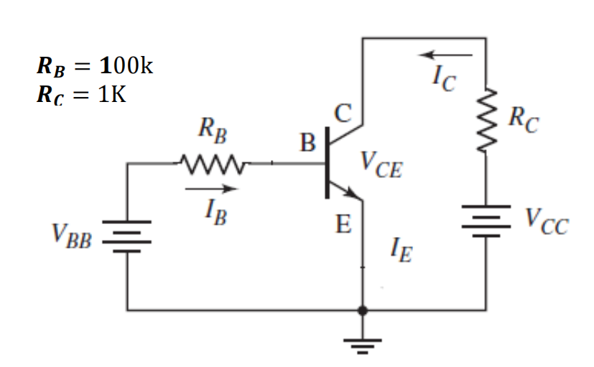

**Experimental Procedure:**

Input Characteristics:

1. We connected the circuit as shown in the circuit diagram.

2. By varying VCC, we made VCE = 1V.

3. Varying VBB gradually, we measured VRB and base-emitter voltage VBE. Then, we calculated IB = . After that, we completed Table 1.

4. Step size is not fixed because of non-linear curve. Initially, we varied VBB in steps of 0.1V.

Once the current starts increasing, we varied VBB in steps of 1V up to 12V.

5. We repeated the above procedure (step 3) for VCE= 5V.

Output Characteristics:

1. We connected the circuit as shown in the circuit diagram.

2. By varying VBB, we made VRB = 1V. This makes IB = 10 μA.

3. Varying VCC gradually in steps, we measured Collector-Emitter Voltage VCE, and . Calculate IC = . Fill up Table-2.

4. We repeated the above procedure (step 3) for IB = 50 μA. [VRB= 5V]

**Experimental Data Table:**

**Results:**

In this experiment, we have observed the input-output characteristics of a common-emitter BJT. During the observation of input characteristics, when the input side voltage is varied while keeping the output side voltage constant, it was found that the voltage across the base-emitter junction did not change much after 0.6 volts. Although the voltage was nearly constant, about 0.6 volts, the current was rising, indicating that the base-emitter junction acts as a diode where the voltage does not change after the threshold voltage but the current increases.

On the other hand, observing the output characteristics, fixing IB at the input side and varying output side voltage, the voltage across the collector-emitter and the resistor in series rose proportionately. The collector current IC was found in milliamperes, whereas IB was in microamperes. From here we can conclude that the BJT works as an amplifier as it amplifies the output current in the circuit.

**Questions and Answers:**

**1. Plot IB vs. VBE for different values of VCE.**

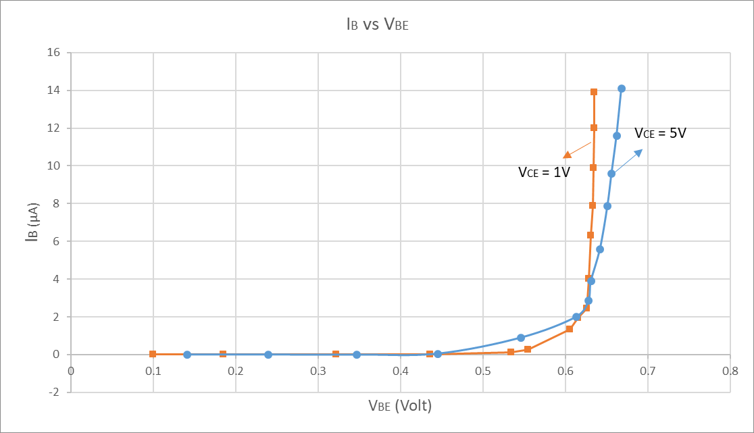

**2. Plot IC vs VCE for different values of IB. Show different regions of operations.**

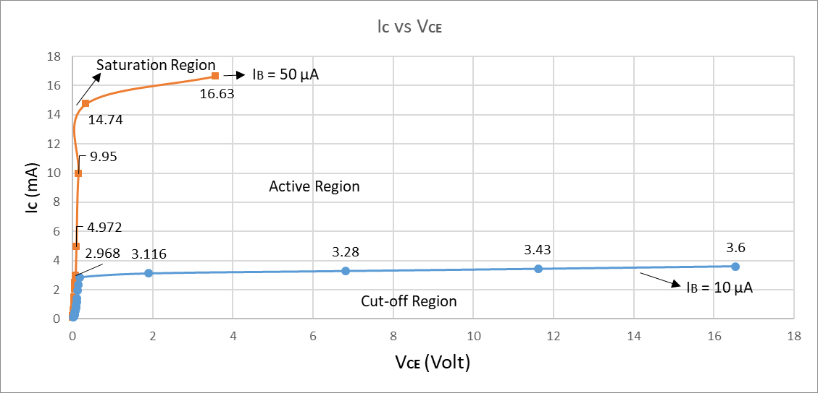

**3. Find β for the each IB [for active region only]**

**Ans.** For each IB , β =

At IB = 50 μA, VCC = 5V, VCE = 0.096V & IC = 4.972mA

Therefore, β = 99.44

At IB = 10 μA, VCC = 5V, VCE = 1.9V & IC = 3.116mA

Therefore, β = 311.6

**4. For VCC = 15V, draw the load line and write the coordinates of the Q-point.**

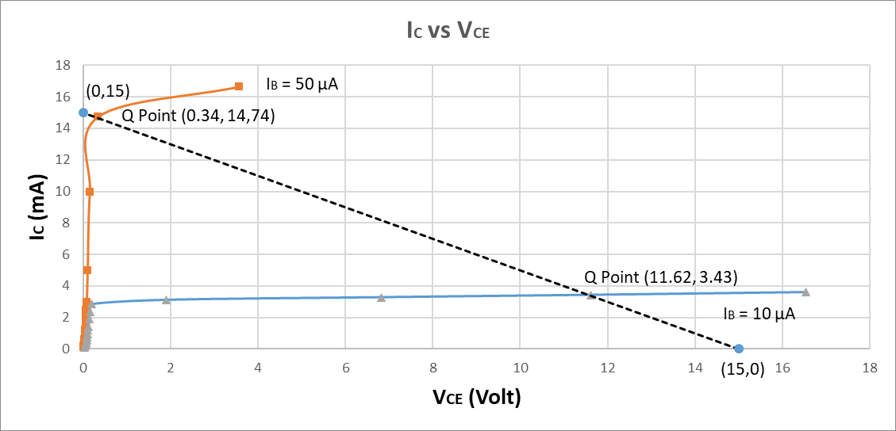

We know that, VCE = VCC-ICRC

When IC = 0 mA, VCE = VCC - 0 = VCC = 15V

When VCE = 0 V, 0 = VCC - ICRC

IC = = = 15 mA

So, plotting and connecting the points (0, 15) and (15, 0) give us the load line; the points at which the load line intersects the curves are the Q-points. Therefore, for IB= 10 μA, the Q-point is (11.62, 3,43), and, for IB= 50 μA, the Q-point is (0.34, 14.74).

**5. Which region of operation does your Q-point cut?**

**Ans.** From the graph, we can observe that the Q point cuts the **active region** of operation.

**6. Explain whether your transistor performed as an amplifier or not.**

**Ans.** The transistor performed as an amplifier as the Q-point of the biased point is within the active region of the transistor.

**Discussion:**

In this experiment, we investigated how a Bipolar Junction Transistor (BJT) works in a common emitter (CE) setup, emphasizing on its behavior in three regions: saturation, cutoff, and active. We learnt how to use this configuration as an amplifier by simulating input and output curves, which show that a little change in input creates a bigger change in output. We had challenges, such as getting stable readings on the multimeter and carefully changing the voltages, as BJTs are sensitive to slight changes. To resolve these issues, we checked the connections, carefully adjusted the voltage, and repeated the readings for added accuracy. In the end, the experiment demonstrated that in the active area, the BJT successfully amplified the input signal, proving its use in electronic circuits.

**Simulation:**

